**SysBio Questionnaire for AS#8**

Name: Choi Yunyoung ID: 22100748

**NOTE: Answers for questions shown below should be written in English only. Points may be deducted if the sentence is incomplete, grammar is seriously wrong, or it is difficult to understand due to incorrect use of words and terminology.**

*As we have studied so far, mathematics is a powerful tool to model dynamic processes in biology. Simple formulas can relate, for instance, the population of a species in a certain year to that of the following year. Although many of the models such as the May models may at first seem to be gross simplifications, their very simplicity is a strength. Simple models clearly show the meaning of the most basic assumptions. In this assignment, we want to focus on modeling the way populations grow or decline over time.*

1. Your first plot shows the prediction results of the Malthusian model and the May model. **1) Initially, the population grows at a similar rate in both models. Why? 2) The difference between populations predicted by the two models gets bigger and bigger as time goes by. Why? 3) The biggest difference between these models is the assumptions behind the model equations. What is the difference between those assumptions?**

| 1. If the population is too small, it is an ideal situation.   When the population is small in Malthusian model,  deltaP/P = lambda -1 (Pn = lambda^n * P0)  (lambda -1) is the maximum value of growth rate in the May model.  r= lambda -1 = (1+f-d) -1 = f-d  Also, (f-d) is the constant growth rate of the Malthusian model.  So, in the initial situation, the population grows at a similar rate in both models because of the similar growth rate.   1. The Malthusian model assumes that the population grows exponentially without any constraints. However, in reality, populations are limited by the availability of resources, which can eventually lead to a decrease in the growth rate. The May model takes into account the carrying capacity of the environment, which is the maximum population size that can be supported by the available resources. The model assumes that the population growth rate decreases as the population approaches the carrying capacity. As a result, the May model predicts that the population growth rate will eventually decrease and stabilize at the carrying capacity, resulting in a sigmoidal curve. In contrast, the Malthusian model predicts exponential growth that continues indefinitely, without any limits. 2. The assumption of the Malthusian model is that the fecundity(f) and death rates(d) for a population are the same regardless of the size of the population. But the assumption of the May model is that the f and d are dependent on the current population density(D). The major difference between these two assumptions is the dependency on the size of the current population. The Malthusian model does not consider the size of population. The May model assumed that as the population size increases, the finite growth rate decreases linearly as individuals compete for both food and space. |
| --- |

1. Cobwebbing is a graphical technique for understanding the dynamics of nonlinear recursive models such as the May model. This example cobweb plot is generated with a toy equation: *Pt+1*  = *Pt* + 0.7 * *Pt* * (1 - *Pt* / 10). If the initial population *P0* is anything between 0 and *K* = 10, then the model will result in an increasing population that approaches the carrying capacity *K = 10*. In other words, regardless of initial value, after many time steps have passed, the model seems to settle down into a pattern. On the other hand, if *P0* > K (e.g. *P0* = 18), the model exhibits previously unseen behavior. **1) Describe how the model’s behavior differs from the previous behavior. 2) Under the given condition, is the unseen behavior transient or permanent?** 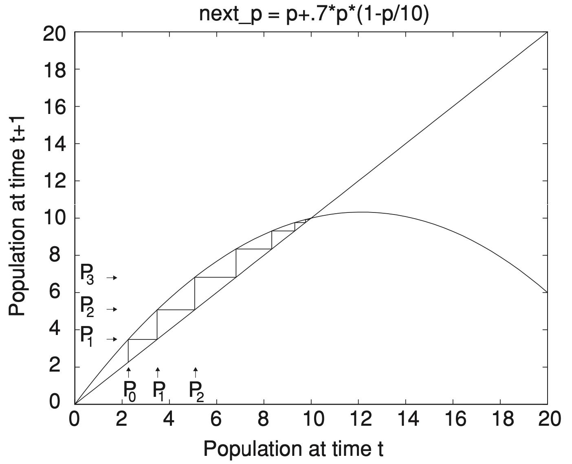

Also, if *P0* = 10 exactly, then the next population *P1* = 10 as well and the population will never change. Thus, we know that *P* = 10 is an equilibrium (or steady-state or fixed point) of the model. **3) In fact, *P* = 10 is not the only equilibrium point in this model. What is the other equilibrium point?**

| 1. When P0<K, population increases and then converges to K.     However, when P0 > K, it can be seen that population decreases and eventually converges to K again. When the maximum population is exceeded, the total population is decreasing due to the influence of the growth rate.     1. In the given condition P0 > K, it shows unseen behavior that population decreases, increases, and converges again. Since Pt+1 no longer increases when Pt is 30, we can see a transient strange shape when initial P0 is between 20 and 30.   Therefore, it can be divided into three sections. Population increases when initial P0 is 0-10, decreases when it is 10-20, and increases, decreases when it is 20-30, and maintains equilibrium. I think it's a transient behavior.     1. I think P=0 is also the equilibrium point. |
| --- |

1. Equilibria of a dynamic model can have different qualitative features. In the example model (*r* = 0.7 and *K* = 10), *P* = A and B are both equilibria, but a population near A tends to move away from A, whereas one near B tends to move toward B. Thus, A is an unstable or repelling equilibrium, and B is a stable or attracting equilibrium. **1)** **What are the values of A and B?** **2) The equilibrium values are determined by a parameter in the May model. Is it the parameter *r* or the parameter *K* ? And why is that?** Note: As long as the model has a stable equilibrium, no matter where the population starts (larger or smaller than K), it will eventually reach the stable equilibrium.

| 1. As you can see from the graph in question 2, P0=0 and P0=10 reach equilibrium, so they can be A and B.   When P0 = 0, the right-hand side of the equation becomes zero, which means that the population at the next time step will also be zero. It is an unstable equilibrium because any small perturbation, such as a single individual being introduced into the population, will cause the population to grow exponentially and move away from zero.  When the population starts out slightly above or below the equilibrium point(here, P0=10), it will move away from it initially due to the logistic growth equation in the May model. However, as time goes on, the population will approach the equilibrium point and eventually stabilize at it. This is because the logistic growth equation models the carrying capacity of the environment, which means that the population growth rate will decrease as the population approaches the carrying capacity K.  Therefore, P0 = 10 is a stable state because the population will eventually settle down at the equilibrium point.  So, A=0, B=10.   1. The equilibrium values of the May model are determined by the parameter K, the carrying capacity. This is because the carrying capacity represents the maximum number of individuals that the environment can support, and as the population approaches this limit, the growth rate slows down and eventually stops. Therefore, the equilibrium point is reached when the population equals the carrying capacity, and this is determined by K. The parameter r, the intrinsic growth rate, affects the dynamics of the system and the speed at which the population approaches equilibrium, but it does not determine the equilibrium value itself. |
| --- |

*As we discussed in the class, the parameter K in the model is not really important; we can choose the units in which we measure the population so that the carrying capacity becomes always 1. For example, if the carrying capacity is 10,000 organisms, we could choose to use units of 10,000 organisms, and then K = 1. This observation lets us focus more closely on how the parameter r affects the behavior of the model. A good way of understanding the effect of changing r on this model is through the bifurcation diagram. In the bifurcation diagram, if the parameter* ***r is larger than a certain value****, the stable equilibrium* ***becomes unstable****. In other words, the May model will have two unstable equilibria and no stable ones: the population no longer approaches an equilibrium. Thus, we can conclude that the parameter r determines the stability of the equilibrium. Use your bifurcation diagram to answer the questions below.*

1. In the bifurcation plot generated by your May model (*K* = 1000, *P0* = 50), the point at which the first bifurcation begins is the place where stable equilibrium becomes unstable. **1) What is the value of *r* at that point? 2) Why does the population not converge to a single stable value after a long period of time when the value of *r* is larger than a certain value?** Please explain using an example.

| 1. I think r=2, where stable equilibrium becomes unstable. As you can see from the graph, when r=2, the equilibrium value starts to split in two for the first time.      1. The logistic growth model is nonlinear, which prevents the population from eventually converging to a single stable value over an extended period of time when r is greater than a particular value. The population growth rate grows as the population size increases up to a certain point and then falls as the population approaches the carrying capacity K because the logistic equation has a sigmoidal shape. When r is big, the growth rate can get really steep, which makes the population fluctuate wildly and unpredictably. |
| --- |

1. The May model, the simplest nonlinear recursive model, tells us an interesting biological conclusion: It is possible for a population to exhibit cycles even though the environment is completely unchanging. If the model’s assumptions are correct and a population has a sufficiently high value of *r* , it may never reach a single equilibrium value. And if the value of *r* gets even larger, unpredictable (chaotic) behavior begins to appear, starting from any initial population except for the two equilibrium points. Please write down what you learned from this assignment or what was most memorable to you (Any answer will earn points).

| It was amazing that such a variety of variables could be created with just a simple linear relational expression called growth rate. In fact, there will be more variables in real situations, but I thought there would be more to consider than I thought when implementing this model on a computer, so the phrase ‘simple is the best’ seems to come to me a lot. |
| --- |

1. Do you have any questions or things you don't understand on this topic? (Any question you ask will earn points)

| When drawing a cobweb plot, is it the simplest code to draw a vertical line and a horizontal line separately? I wonder how I can draw cobweb because I think there is a better way. |
| --- |